**Letter**

Letter writing is a skill people need for personal, professional and academic purposes. Letters come in many forms, from digital to hard copy and informal to formal. Knowing how to format and write effective letters when corresponding with professionals as well as acquaintances.

**Types of Letter**

**Formal Letters**

The letters that follow a certain formality and set pattern are formal letters. Such letters are precise, directly addressing the concerned issue and are kept strictly professional in nature. Formal letters are short and to the point. A variety of letters that fall within the category of formal letters are –

* Business letters
* Official letters
* Social letters
* Circular letters
* Employment letters

**Letter writing format of Formal Letter**

A formal letter must adhere to the prescribed format. The letter writing format of a formal letter is as mentioned below:

|  |
| --- |
| 1. Sender’s address 2. Date 3. Receiver’s address 4. Subject 5. Salutation 6. Body of the letter 7. Complimentary closure 8. Signature line: sender’s name, signature and designation |
|

* Sender’s address: One of the most essential components, also known as the return address. It is the mailing address of the sender. The address and contact details of the person sending the letter are written here.
* Date: Immediately after the sender’s address comes the date on which the letter is written. Candidates, while writing the letter in the exam, can follow any of the formats to write the dates: DD/MM/YY OR MM/DD/YY.
* Receiver’s address: The corresponding address, i.e. the address of the recipient of the mail is written here. Candidates must start with the receivers’ designation followed by the name of the organization and then the full address, Pincode and country (if the information is known).
* The subject: This highlights the aim of writing the letter. The subject of the formal letter should be very brief (6 to 8 words) and must be preceded by the word ‘Subject’. The receiver, through the subject, understands the purpose of the letter at a glance.
* Salutation: This is a customary greeting to the recipient of the letter. If the name of the recipient is known, the salutation starts with ‘Dear’ followed by Mr/Mrs/Miss, etc. If the person is unknown or even the gender is not known the recipient can be addressed as Dear Sir/Dear Madam.
* Body: The most important element of any letter. It furnishes the reason behind writing the letter. For formal letters, candidates should use short, clear, logical paragraphs to state the subject matter. The body of the letter is generally divided into 3 paragraphs:

1. Introduction that states the main point.
2. Middle part: Supporting points and details to justify the need and importance of letter writing.
3. Conclusion: Request for some action or what is expected.

* Complimentary Closure: This is to end the letter with respect in a polite manner such as ‘Yours faithfully’, ‘Yours sincerely’, etc.
* Signature Line: This is the last part where the sender of the letter signs off with his first or last name. The signature line may also include a second line for the title or designation of the sender.

Candidates writing formal letters in the exam must remember the following pointers.

* Use of colloquial words, short forms, slang language and abbreviations are restricted.
* The letter must be to the point, precise and clearly indicating the message.
* The subject line is very important in Formal Letters.

### Important Tips for Good Letter Writing

Candidates appearing for competitive exams are encouraged to follow the below-mentioned tips to write a good letter in the examination and fetch good marks.

* Candidates must be able to identify the type of letter they will write. For example: writing a letter to the Principal asking for leave is a formal letter, but writing a letter to the Principal to catch up after a long time would be an informal letter.
* Opening and closing of letters must be in the correct manner. Formal letters must open and close in a professional manner while informal letters can be directly addressed to the person with greetings. Even closing the letters is significant. Formal letters always end respectfully and impersonally, whereas informal letters may end with a more personal touch.
* In formal letters, making clear the purpose of the letter immediately is important. Candidates writing formal letters must make sure to get to the point as soon as possible.
* A letter is always supposed to be considerate and polite. It is essential to use polite words and civil language in all types of letters, be it formal or informal. Even if the letter is about any complaint, the point must be made in a careful and courteous manner.
* The length of the letter also holds relevance. In formal letters, the matter should be expressed to the point, precise and short, while the length of the personal or informal letter depends on the message and the relation to the recipient.

## ****Business Letter****

A business letter is a professional, formal letter that is sent by one company to another. These letters can be used for professional correspondence between business clients, employees, stakeholders as well as individuals.

Whether you need to tell a potential client about your product, collaborate with another company, convince someone to attend your event, or give a thank you note – a **well-written business letter** can stand out.

### ****Cover Letters****

First up, a cover letter is a one-page document that candidates submit along with their resumes. It takes the employer on a guided journey of their greatest career & life achievements.

No matter if you’re a student or an experienced professional, a cover letter is an important document to show your skills, experience, and why you’re fit for the position you are applying for.

**Tips:**

* Don’t try to fit your whole career in your cover letter. It should have a carefully curated collection of stories.
* Don’t state a skill that you don’t actually have. You’ll definitely regret it when you’re asked to use that skill in the interview.
* Keep it concise and to the point. The employer does not have time to sit down and read an entire memoir.

### ****Letter of Resignation****

A letter of resignation is a document that notifies your employer that you’re leaving your job. Whether you work at a coffee shop or a big-shot company, it’s proper protocol to submit a letter of resignation before you leave.

Also, if you have an urge to send an incendiary letter of resignation, don’t give in! You might cross paths with these people again.

**Tips:**

* Keep it simple, stick to the facts, and don’t start complaining. Resignation letters are not the right place for complaints & critiques.
* Thank your boss and/or the company for the opportunities and describe some of the key things you learned on the job.
* If you’re in a high-profile position, consider your words super carefully because your letter would likely be made public.

**E-mail**

E-mail is familiar to most students and workers. It may be used like text, or synchronous chat, and it can be delivered to a cell phone. In business, email has largely replaced print hard copy letters for external (outside the company) correspondence, and in many cases, it has taken the place of memos for internal (within the company) communication.E-mail can be very useful for messages that have slightly more content than a text message, but it is still best used for fairly brief messages. Many businesses use automated e-mails to acknowledge communications from the public, or to remind associates that periodic reports or payments are due.

Email writing is an essential part of professional communication. It is not easy to get people to respond to your emails if they do not feel interested in your message or proposal. This is exactly the reason why you should learn to write good emails. Be bold. Get to the point right away. The best email communication is the one that is simple and clear.

# Parts of an email message

An email message consists of the following general components:

### Headers

The message headers contain information concerning the sender and recipients. The exact content of mail headers can vary depending on the email system that generated the message. Generally, headers contain the following information:

* **Subject.** Subject is a description of the topic of the message and displays in most email systems that list email messages individually. A subject line could be something like "2010 company mission statement" or, if your spam filtering application is too lenient, "Lose weight fast!!! Ask me how."
* **Sender (From).** This is the sender's Internet email address. It is usually presumed to be the same as the Reply-to address, unless a different one is provided.
* **Date and time received (On)**. The date and time the message was received.
* **Reply-to.** This is the Internet email address that will become the recipient of your reply if you click the Reply button.
* **Recipient (To:).** First/last name of email recipient, as configured by the sender.
* **Recipient email address.** The Internet mail address of the recipient, or where the message was actually sent.
* **Attachments**. Files that are attached to the message.

### Body

The body of a message contains text that is the actual content, such as "Employees who are eligible for the new health care program should contact their supervisors by next Friday if they want to switch."  The message body also may include signatures or automatically generated text that is inserted by the sender's email system.

# TIPS FOR EFFECTIVE BUSINESS E-MAILS

As with all writing, professional communications require attention to the specific writing context, and it may surprise you that even elements of form can indicate a writer’s strong understanding of audience and purpose. The principles explained here apply to the educational context as well; use them when communicating with your instructors and classroom peers.

* **Open with a proper salutation**. Proper salutations demonstrate respect and avoid mix-ups in case a message is accidentally sent to the wrong recipient. For example, use a salutation like “Dear Ms. X” (external) or “Hi Barry” (internal). Never use the title Mrs. as you cannot assume a woman is married. If the gender of a person is not evident, use their entire name, like this: “Dear Sam Jones”
* **Include a clear, brief, and specific subject line**. This helps the recipient understand the essence of the message. For example, “Proposal attached” or “Your question of 10/25.”
* **Close with a signature**. Identify yourself by creating a signature block that automatically contains your name and business contact information.
* **Avoid abbreviations**. An e-mail is not a text message, and the audience may not find your wit cause to ROTFLOL (roll on the floor laughing out loud).
* **Be brief**. Omit unnecessary words.
* **Use a good format**. Divide your message into brief paragraphs for ease of reading. A good e-mail should get to the point and conclude in three small paragraphs or less.
* **Reread, revise, and review**. Catch and correct spelling and grammar mistakes before you press “send.” It will take more time and effort to undo the problems caused by a hasty, poorly written e-mail than to get it right the first time.
* **Reply promptly**. Watch out for an emotional response—never reply in anger—but make a habit of replying to all e-mails within twenty-four hours, even if only to say that you will provide the requested information in forty-eight or seventy-two hours.
* **Use “Reply All” sparingly**. Do not send your reply to everyone who received the initial e-mail unless your message absolutely needs to be read by the entire group.
* **Avoid using all caps**. Capital letters are used on the Internet to communicate emphatic emotion or yelling and are considered rude.
* **Test links**. If you include a link, test it to make sure it is working.
* **E-mail ahead of time if you are going to attach large files** (audio and visual files are often quite large) to prevent exceeding the recipient’s mailbox limit or triggering the spam filter.
* **Give feedback or follow up**. If you don’t get a response in twenty-four hours, e-mail or call. Spam filters may have intercepted your message, so your recipient may never have received it.

**Types of E-mail**

1. Formal email
2. Informal email

Formal email writing is usually in a B2B or B2C scenario or a professional email between colleagues, businesses, or partners.

Informal email writing is something you might send a friend, family member, or sometimes even a quick email you’re firing off to a colleague.

## Basic formal email structure

Before we get into different email templates, it’s important to know how to build an email yourself. For the most part, every email, regardless of its contents, will follow the same structure with the same basic elements. You should get to know these elements in order to ensure proper and effective email writing as a whole.

**The basic elements of professional email writing (Formal e-mail)**

1. Your email address
2. Subject line
3. Email opening
4. Email body
5. Email ending
6. Email Sign off
7. Email signature/footer

## Email Writing Format Samples

Here are some sample emails that will help you understand how to write an email in the best possible way.

### Informal Email Writing Format Samples

#### Email Expressing Your Appreciation

To: Recipient’s email address

Subject: Congratulations!

Dear (Name),

My heartfelt congratulations to you. I was glad to see your name on the merit list. All your efforts were definitely not in vain. I bet everyone at home is so proud of you.

You have truly honoured the family name, and I am happy that you would get to take up the course in architecture that you had been waiting for. I am waiting to meet you in person to convey all my love and appreciation.

Convey my regards to uncle, aunty and grandpa.

Regards,

Your name

#### 

### Formal Email Writing Format Samples

#### Email on Seeking Information Regarding Course Details

To: Recipient’s email ID

Subject: Regarding Course Details

Dear Sir,

I have passed the B.Sc. degree examination with Electronics as the main subject. I intend to have a course in Computer Science and would like to know the details of the courses taught at your institution. Could you please send me a copy of your prospectus?

Yours faithfully,

Your name

**Letter Vs E-mail**

**Letter** is a form of written communication addressed outside the organization. It contains a long formal message to inform someone of a specific topic. The tone of the letter depends on the relationship between sender and recipient.

**Email** is another form of routine electronic communication within an organization or outside the organization. It requires an email account and internet connection.

## Differences

The major differences between Memo, letters, and Emails are as follows −

| **Letter** | **Email** |
| --- | --- |
| Long and informative | Informal and routine message. |
| Duly signed by the sender. | A signature is used as a complimentary closing of the message, which is automatically inserted. |
| It is exchanged between the company and the client. | It can be exchanged between anyone. |
| It does not contain any header. Formal language is used to convey information to a specific person. | It contains an introduction, body, a closing, subject line, and recipient's email id. |

**Introduction to DOs**

**Demi official letter**

Demi official letter explanation is the letter that communicates official e-mail along with personal news is called demi-official, it is also known as Demi government letter. In other words, the official letter that contains some personal information along with official information is known as a demi-official letter.

The [official letter](https://qsstudy.com/meaning-official-letter/) that contains some personal information along with official information is known as a demi-official letter. This letter is generally written by compiling both official and some sort of personal messages. This form is generally used in correspondence between Officers to supplement or explain matter which has been referred officially or is proposed to be referred officially.

In writing this letter officially recognized rules, procedures and structure are not followed. Though this letter includes both personal and official information, official information gets the prime focus. People bolding the same position or rank usually exchange this type of letter. In this letter, the receiver is addressed by name. It is to be written in the first person in a personal and friendly tone and it should be addressed by an Officer who is ordinarily not more than one or two levels below the Officer to whom such communication is addressed. Demi-official correspondence should not be quoted in official communications or be noticed officially in any way.

Actually, a Demi-official letter is official in reason but involves some personal association or touch. This letter is usually written by compiling both official and some kind of personal messages. It is not as formal as the official letter. This type of letter does not follow any established structure. Use of language in this letter depends on a personal relationship between sender and receiver. It is not written by using customary official language. Writers can follow any formation as they think.

Some important points regarding Demi-official letter are noted as under:

* It is usually addressed by the name and title of the person who is thought to attend to the focus subject of the letter.
* Salutation normally starts with ‘My Dear X’ ‘Dear Mr./Mrs. Y’
* The appropriate manner of a subscription is ‘Yours sincerely’
* Such a letter is signed by the officer concerned and not by someone else on behalf of the officer.

## Notice

## Notice Writing Format

A notice is a written or printed message or information that is shown prominently or published in newspapers or periodicals. A notice’s tone and style are formal and factual, using straightforward and formal language because it includes a formal notification or information. Rather than being lengthy, notices are always brief and to the point.

Below mentioned are some of the important tips that you should know:

* At the top, write the word NOTICE.
* Include all pertinent information (date, venue, time) and also the notice’s purpose.
* The individual issuing the notice’s signature, name, and designation, along with the name of the organisation responsible for issuing the notice must be provided.
* Placing the notification in a box.
* Stick to the 50-word restriction that has been set.
* The school, organisation, or agency issuing the warning should be identified by name and location.
* Make a suitable and brief heading. It must be relevant to the material to be discussed. The reader should be able to figure out what the notification is about at first glance. and then devise a strategy of action.
* The goal of the notice, its terms, pertinent information, or other elements must all be stated briefly in the body of the notice. It must also be brief while still being comprehensive.
* Indicate the date on which the notice was issued.
* Make it clear who your target audience is (for whom the notice is to be displayed).
* Finally, check the text for spelling and grammatical errors. Also, make certain that the notice’s text is clear.

## Notice Writing Formats & Sample Examples

**Q. As Principal of Central School, Patna, create a notice of no more than 50 words advising pupils of a change in school hours beginning October 1st. Explain why the modification is necessary.**

**Ans:**

|  |
| --- |
| **NOTICE**  **Central School, Patna**   2nd November 2021  Changes in School Schedules  All students are thus notified of a change in school hours beginning October 1st, 20xx. School will now begin at 9:00 a.m. and end at 3:00 p.m. Winters have been harsher in recent years, making it impossible to start early owing to the extreme cold and dense fog. As a result, these new schedules will be followed until further notice.  Principal |

## Notice Writing Format, Examples, Topics, Samples, Exercises - SchoolNotes24

## Circulars

A circular is essentially a letter containing some important information that is distributed to a large number of people. Say for example you have to invite an entire department for a meeting, or update the dress policy for the whole office – a circular will be the best mode of communication for these purposes. Additionally, circulars also find use as advertising tools. They can contain marketing information and have a wide distribution range. Be it for inter-departmental communication, advertising or even personal reasons a circular must always reach a large number of correspondents. This is one of its main features.

**Agenda**

An agenda, also called a **docket** or a **schedule**, is a list of activities in the order they are to be taken up, from the beginning till the adjournment. An agenda helps in preparing for a meeting by providing a list of items and a clear set of topics, objectives, and time frames that are needed to be discussed upon.

## Format of an Agenda

An Agenda normally includes the following elements −

* **Meeting Agenda Title** − at the top; preferably center-aligned
* **Meeting Information** − Description of the purpose
* **Objective** − description of Agenda
* **Date** − for maintaining records of correspondence
* **Location** − the place of meeting
* **Time** − the actual time of commencement of the meeting
* **Meeting Type** − brainstorming or Discussion or Assessment
* **Time of Arrival** − time to begin the meeting
* **Time of Adjournment** − time the meeting ends
* **Attendees** − Number of people present, with their names
* **Preparation for Meeting** −
  + **Please Read** − instructions to be followed
  + **Please bring** − things supposed to be carried that day
  + **Action Items** −

|  |  |  |
| --- | --- | --- |
| Last Action | Responsible Authority | Due Date |
| New Action | Responsible Authority | Due Date |

* + **Other notes** − other instruction or information to be taken down.

**Example**

**Update after meeting with Hasta La Vista representatives**

**Meeting Information** − Update after meeting representatives of Hasta La Vista.

**Objective** − for the purpose of interior decoration of our office premises.

**Date**- 23rd April, 2015

**Location**- Meeting Room-1

**Time**- 4:30 PM

**Meeting Type**- Discussion

**Time of Arrival**- 6:00 PM

**Time of Adjournment**- 8:30 PM

**Attendees**- Mohtahsim M., Kiran K. Panigrahi, Gopal K Verma, Manisha Shejwal

**Preparation for Meeting**:

**Please Read** - Hasta La Vista Company Brochure, Quotation Document

**Please bring** - Competitor Company’s quotation, hourly rates analysis

**Action Items**:

**Due Action**:

|  |  |  |
| --- | --- | --- |
| Updates from Hasta la Vista | Gopal K Verma | 30th April, 2015 |
| Find Hasta la Vista’s competitor | Manisha Shejwal | 30th April, 2015 |

**New Action:**

|  |  |  |
| --- | --- | --- |
| Send email to their Head of Marketing | Manisha Shejwal | 5th May, 2015 |

**Other notes** - Products to purchase for the interior décor.

**Meeting minutes**

Meeting minutes are the official summary of what happened during a meeting.

They serve as an outline, a written record for anyone unable to attend, and to use for future reference. Minutes document what happened and what decisions were made.

When written well, and when using a good meeting minutes template, minutes are a critical communication tool for your organization.

Meeting minutes are notes that are taken during a meeting to record what happens in the meeting. These notes typically highlight the key issues that are discussed in the meeting. Meeting minutes should indicate the time, date, and setting of the meeting. These notes should also document who was in attendance at the meeting. If there are any presentations or reports presented, these should be reflected in the meeting minutes.

**What should included in minutes**

Here is some necessary information found in most meeting minutes.

1. The title of the group that is meeting, or the meeting itself
2. The date and time, as well as the venue or meeting room, if appropriate
3. Who is in attendance and who is recording the minutes
4. The meeting’s agenda
5. What decisions were made and by whom
6. Motions and vote counts (if applicable)

**Example of Minutes**

**MINUTES OF A MEETING OF THE BOARD OF DIRECTORS**

**September 5, 2021**

A meeting of the Board of Directors (the “**Board**”) of ACME Corp., a California C-Corporation (the “Company”), was held on September 5, 2021, at the offices of the Company.

**Attendance**  
- **Voting Members:** Larry Emerson, Marc Branson  
- **Guests:** Amy Holmes, Tom Avery  
- **Voting Members Absent:** None

**Approval of minutes**  
A motion to approve the previous meeting minutes from August 5th was made by Larry Emerson and seconded by Marc Branson.

**Call to Order**  
‍Larry Emerson called the meeting to order at 2:00 p.m. and Tom Avery recorded the minutes. A quorum of directors was present, and the meeting, having been duly convened, was ready to proceed with the business.

**CEO Report**  
‍Larry Emerson reviewed the agenda and welcomed everyone to the meeting. Next, Larry Emerson discussed the current status of the company and its progress. A number of questions were asked and extensive discussion ensued.

**Sales & Business Development Update Report**  
‍Marc Branson next provided an update on the overall sales progress and sales pipeline of the Company. He also presented the status of business development discussions.

**Financial Review Report**  
‍Marc Branson provided a comprehensive update on the Company's financial plan and forecast. Marc Branson also reviewed the Company's principal financial operating metrics.

**Motion #1: Approval of Option Grants**  
‍Amy Holmes presented to the Board a list of proposed options to be granted to Company employees for approval, whereupon motion duly made, seconded and unanimously adopted, the option grants were approved as presented in Exhibit A.

**Announcements**  
‍None

**Adjournment**  
‍There being no further business to come before the meeting, the meeting was adjourned at 2:45 p.m.

**Curriculum Vitae (CV)**

The term CV is **an abbreviation** of the Latin word **Curriculum Vitae**, which is literally translated to “the course of your life”.

**A CV is** a very in-depth document that describes your career journey step-by-step, including all sorts of personal information. You can look at the CV as a **comprehensive description** of everything you have ever done, all the achievements you are proud of, and all the publications that bear your name.

You need to update your CV every time you accomplish something new academically or professionally. Meaning, whenever you get a new job, publish something new, obtain a new certificate, and so on.

There is no rule of thumb on **how long a CV should be** - depending on the amount of experience, it can range from 2 to 8 pages.

#### What to Include on a CV

1. Full name
2. Contact information
3. Professional title, resume summary, or resume objective
4. Research interests
5. Education
6. Publications (both academic papers and books)
7. Teaching or lecturing experience
8. Work experience
9. Conferences and courses
10. Skills
11. Certificates
12. Languages
13. Grants of fellowships
14. References

In Elizabeth’s CV, you can see a summarized snapshot of her life: everything she has studied, all the conferences she has been to, the skills she obtained, and a list of her publications.

Since she’s applying for a job in a university, Elizabeth mentions her academic achievements and interests first, and professional experiences later.

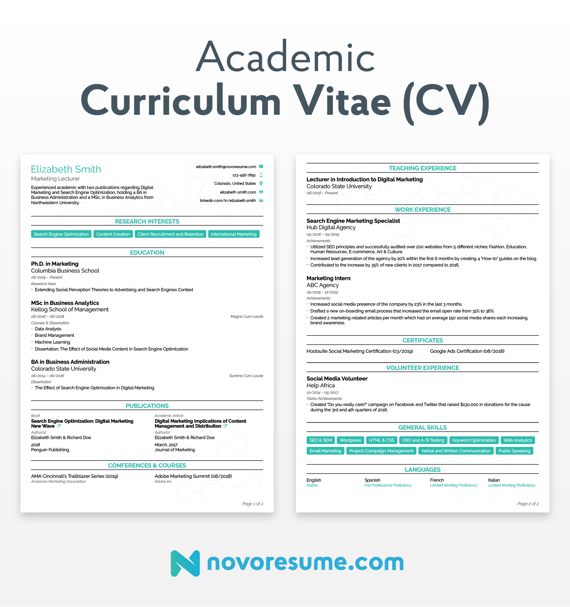

**Resume**

**A resume is** a short, straight-to-the-point, document created for the purpose of applying to a specific job.

Unlike the CV, you should try to**keep a resume as short as possible**. In 99% of the cases, you’d want to keep your resume to 1-page max. If you have 15+ years of experience, or really believe that the extra information you can mention can add value to your application, you can make it 2 pages tops.

In a resume, you only mention the aspects of your work experience and skills that are relevant to the job you’re applying for. A good resume highlights specific contributions you have made in your previous work and showcases how your different skills can be useful for the position you are applying to.

The resume is usually accompanied by the submission of a cover letter which states your intent for applying to the job. The cover letter **builds upon the skills and experience** you have touched upon in your resume, explaining how they’re going to help you excel at the job you’re applying for.

*Making a resume and continuously updating it can be a hassle. Want a modern-looking resume done in less than 5 minutes? Try our online resume builder. It’s free, and you can select amongst 8+ templates.*

#### What to Include on a Resume

1. Full name
2. Your job title, or the name of the position you’re applying for
3. Contact information
4. Resume summary or objective
5. Work experience
6. Education
7. Relevant skills
8. Languages and proficiency
9. Relevant certifications and interests (if any)

**Bio Data**

Since it is an archaic term, Biodatas are not used in a career oriented field anymore. Our parents used to share their biodata when they would go for interviews back in the 70s. Nowadays, Biodata has a reference mostly in case of arranged (or love) marriages where parents ask for it from the other party.

In a bio data, the focus is on personal particulars like date of birth, gender, religion, race, nationality, residence, marital status, and the like. A chronological listing of education and experience comes after that but only to show what a person has done, it is not for the purpose of a job.

In some South Asian countries (e.g. Bangladesh) it may be used in the place of a resume. A biodata form is also required when applying for government, or defence positions.

### Biodata

1. No limit on the pages
2. Focus on Date and Time of Birth, gender, religion, race, nationality, residence, marital status
3. Customised for the purpose of marriages
4. Written in a first or third person tone
5. Education & Experience: not mandatory

**Report Writing**

A report is a brief account of an event that has already taken place. The report helps in recording the events of importance that occur in our day-to-day life. It attempts to present the firsthand information of an incident or event. A report of an event presents a record of events that took place. A report of an event includes one’s ideas, opinions and impressions about the event.

**A report is a short, sharp, concise document which is written for a particular purpose and audience.** It generally sets outs and analyses a situation or problem, often making recommendations for future action. It is a factual paper, and needs to be clear and well-structured.

Requirements for the precise form and content of a report will vary between organisation and departments and in study between courses, from tutor to tutor, as well as between subjects, so it’s worth finding out if there are any specific guidelines before you start.

Reports may contain some or all of the following elements:

* A description of a sequence of events or a situation;
* Some interpretation of the significance of these events or situation, whether solely your own analysis or informed by the views of others, always carefully referenced of course (see our page on Academic Referencing for more information);
* An evaluation of the facts or the results of your research;
* Discussion of the likely outcomes of future courses of action;
* Your recommendations as to a course of action; and
* Conclusions.

Not all of these elements will be essential in every report.

**Kinds of Reports**

**Business Reports**

Business reports are actual documents that inform by summarizing and analyzing a particular situation, issue, or facts and then make recommendations to the group or person asking for the report. The goal of these reports is usually one of the following:

* To examine potential and available solutions to an issue, situation, or problem
* To apply business and management theories to produce different suggestions for improvement
* To show your evaluation, reasoning, and analytical skills in recognizing and considering possible solutions and outcomes
* To make conclusions about an issue or problem
* To produce a range of suggestions for future action
* To present clear and concise communication skills

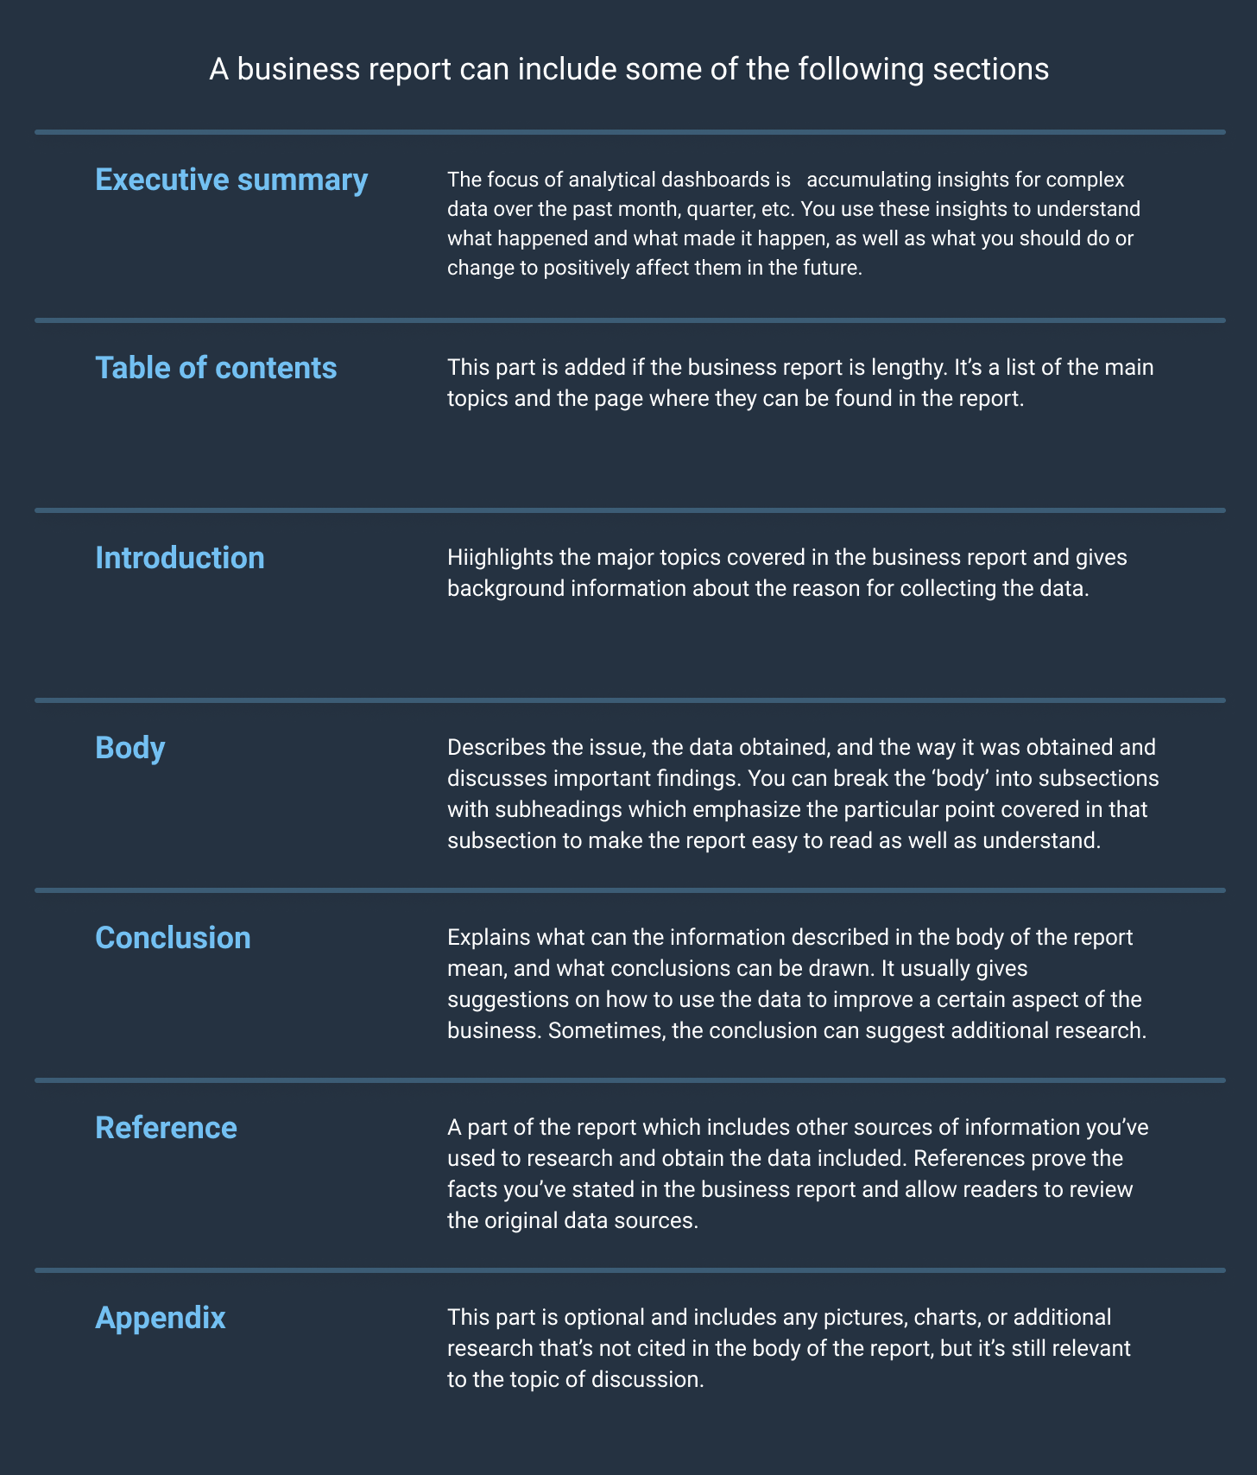

***Informational Reports***

You ask for this report when you want objective information on something. It presents non-biased facts without explaining the reasons and the possible outcomes of a situation. It is the ideal business report for learning things such as the number of employees, the role each of them plays in the company, or the departments the employees work in.

***Analytical Report***

This type of business report is usually required when a company is trying to make an important decision. An analytical report analyzes the company’s situation, presenting relevant information, explanations, and conclusions. It helps the company to make good decisions going forward.

***Research Report***

This is the most comprehensive type of business reports required when a company considers trying something new, such as going into a new geographical area or offering a new product. A team of specialists or researchers are given a topic and asked to find all the relevant statistics and details obtained from an informational report, followed by a detailed analysis of the data found in the analytical report. The conclusion of the research report will be based on the available data obtained from the analytical and informational reports.

***Progress Report***

You want this report to show how things are going at the moment. A progress report isn’t based on analysis or tons of research. Instead, they are an update for the person who needs it. One example of this could be a weekly report disclossing the progress made throughout the week and what tasks you're looking to work on in the upcoming week.

**Technical Report**

A technical report usually is more detailed than an article published in a journal or a paper presented at a conference. It contains sufficient data to enable a reader to evaluate the investigative process of original research or development. It is an end product of an investigation, survey, research project etc. Technical report, the primary recording medium for R & D work, has become an important source of information in recent years. This is mainly because of the time consuming routines of publication procedures of journals and their preference to publish completed research as against research in progress. But many a time, the nature of communication does not require wide dissemination and so a technical report is brought out. Further, the government-funded research results in the areas of space, nuclear sciences, and defense is generally shrouded under secrecy and national security and so is circulated to a very limited people. All these factors have resulted in the emergence of the technical report, which is issued in different sizes and formats.

Technical reports are characterized by their objectivity and targeted audience. They define the problem, analyze and assess the current and future conditions, describe the method experiment to solve a problem, discuss the results, draw conclusions and recommend future course of action.

**Types of Technical Reports**

Technical reports include technical papers, memoranda, proposals, progress and status reports, feasibility reports, technical manuals, investigation reports etc. A technical report may be a letter, an article, a research paper, an operational manual, a news bulletin, a company brochure, a book review etc. It includes preprints, institutional reports, and committee reports also under technical reports literature. Depending on the purpose and information content, reports can be classified as informal and formal reports.

**Informal reports** usually present the results of investigations and convey information of products, methods and equipment. The informal nature makes these more accessible, and easy to be adapted to any situation. These are generally meant for immediate superiors and colleagues in an institution. Analysis reports, trip reports, laboratory reports, field reports, inspection reports, etc.

**Formal reports** provide information which is needed by the management for decision making. Thus a formal report will have a larger target readership as compared to the informal report, and serve as a main source of information. Formal reports include project proposals, progress or status reports (half-yearly, annual etc), state of-the-art reports and review reports, trend or critical evaluation reports, feasibility reports, etc. Types and characteristics of some of the above mentioned reports are briefly described in the following paragraphs.

**Committee Reports** Many a time when a major decision is to be taken, the government or its department constitutes committees to go into various aspects of the issue. These issues include policy formulation, restructuring the organisation, prevention of losses due to hazards, etc. Usually, all the members in such committees will be experts in their fields and these reports provide very valuable information, including the pros and cons of an issue and a plan of action.

**Feasibility Reports** These reports discuss the practicality, in physical and economic terms, of a new project (for example, feasibility reports on the establishment of DELNET, CALIBNET etc), new product development of a new program, purchase of a equipment plant or machine, or reallocation of a factor?; site. A feasibility report generally includes explanation of the problem, present standards on criteria, subject-items to be analysed, and examination of the scope of analysis. Feasibility reports may also include cost-effective analysis. Alternative routes available to complete the project and a minimum time required to achieve a breakeven point in cases where returns are expected.

**Institutional Reports** These reports describe the activities and progress of projects. Undertaken by an institution or establishment. These include technical information on programs, details of infrastructural and manpower resources, and summaries of research undertaken during the period of the report. As such these reports provide valuable information not available elsewhere. The annual reports of the government departments and agencies, private and public R&D laboratories, and professional societies belong to this category of reports.

**Reprints**

These can be taken as the informal reports of individual authors. These are circulated to the colleagues or professionals who are working in the same field for their comments. The relevant comments made by them, if any, are incorporated and then submitted to a primary journal or presented in a conference/symposium. The format of the preprint will be that of a research paper published in a professional periodical.

**Proposal**

**Project Proposals**

Project proposals are chiefly prepared for getting sanction of projects or approval of a developmental works or getting grants and contracts. These are not circulated before or after the purpose for which they were prepared. Most of the times, the information included is proprietary in nature. These are different from other types of reports because they deal with future plan of action and method of implementation of a project. The main characteristics of a proposal are the statement of intention, willingness, and qualifications and expertise to accomplish a task as per a definite time schedule. This may also include information about the capabilities of existing facilities, financial, infrastructural and manpower considerations. Convincing the peers to obtain financial support or sanction of project is a hidden function of a proposal. Generally, proposals include a letter of transmittal. Title, executive summary, table of contents, introduction, overview analysis of the problem, statement of the problem, methodology and infrastructural facilities needed to complete the project.

**Technical Proposal**

A technical proposal is a document that contains an introduction to the product, an explanation of how it will help address the recipient’s problem, the company’s execution plan, and technical details of the deal.

**Elements of Proposal**

**Introduction and Theoretical Framework**

A.                 “The introduction is the part of the paper that provides readers with the background information for the research reported in the paper. Its purpose is to establish a framework for the research, so that readers can understand how it is related to other research”.

B.                 In an introduction, the writer should

1.                  create reader interest in the topic,

2.                  lay the broad foundation for the problem that leads to the study,

3.                  place the study within the larger context of the scholarly literature.

.

C.             Theories, theoretical frameworks, and lines of inquiry may be differently handled in quantitative and qualitative endeavors.

**II.               Statement of the Problem**

A.                 “The problem statement describes the context for the study and it also identifies the general analysis approach”

 It is important in a proposal that the problem stand out—that the reader can easily recognize it. Sometimes, obscure and poorly formulated problems are masked in an extended discussion. In such cases, reviewers and/or committee members will have difficulty recognizing the problem.

A problem statement should be presented within a context, and that context should be provided and briefly explained, including a discussion of the *conceptual or theoretical framework* in which it is embedded. Clearly and succinctly identify and explain the problem within the framework of the theory or line of inquiry that undergirds the study.

**III.           Purpose of the Study**

 “The purpose statement should provide a specific and accurate synopsis of the overall purpose of the study”. If the purpose is not clear to the writer, it cannot be clear to the reader.

Briefly define and delimit the specific area of the research. You will revisit this in greater detail in a later section.  Foreshadow the hypotheses to be tested or the questions to be raised, as well as the significance of the study. These will require specific elaboration in subsequent sections.

**IV.           Review of the Literature**

“The review of the literature provides the background and context for the research problem. It should establish the need for the research and indicate that the writer is knowledgeable about the area”.

   The literature review accomplishes several important things.

1.                  It shares with the reader the results of other studies that are closely related to the study being reported.

2.                  It relates a study to the larger, ongoing dialogue in the literature about a topic, filling in gaps and extending prior studies.

3.                  It provides a framework for establishing the importance of the study, as well as a benchmark for comparing the results of a study with other findings.

4.                  It “frames” the problem earlier identified.

**V.               Questions and/or Hypotheses**

A.                 *Questions* are relevant to normative or census type research (How many of them are there? Is there a relationship between them?). They are most often used in qualitative inquiry, although their use in quantitative inquiry is becoming more prominent. *Hypotheses* are relevant to theoretical research and are typically used only in quantitative inquiry. When a writer states hypotheses, the reader is entitled to have an exposition of the theory that led to them (and of the assumptions underlying the theory). Just as conclusions must be grounded in the data, hypotheses must be grounded in the theoretical framework.

**VI.           The Design--Methods and Procedures**

A.                 “The methods or procedures section is really the heart of the research proposal. The activities should be described with as much detail as possible, and the continuity between them should be apparent”.

B.                 Indicate the methodological steps you will take to answer every question or to test every hypothesis illustrated in the Questions/Hypotheses section.

E.            **Sampling**

1.                  The key reason for being concerned with sampling is that of *validity—*the extent to which the interpretations of the results of the study follow from the study itself and the extent to which results may be generalized to other situations with other people.

2.                  Sampling is critical to *external validity*—the extent to which findings of a study can be generalized to people or situations other than those observed in the study. To generalize validly the findings from a sample to some defined population requires that the sample has been drawn from that population according to one of several *probability* sampling plans. By a *probability sample* is meant that the probability of inclusion in the sample of any element in the population must be given *a priori*. All probability samples involve the idea of *random sampling* at some stage (Shavelson, 1988). In experimentation, two distinct steps are involved.

F.  **Data Collection**

1.                  Outline the general plan for collecting the data. This may include survey administration procedures, interview or observation procedures. Include an explicit statement covering the field controls to be employed. If appropriate, discuss how you obtained *entré*.

2.                  Provide a general outline of the time schedule you expect to follow.

G.                 **Data Analysis**

1.                  Specify the procedures you will use, and label them accurately.

**VII.        Limitations and Delimitations**

A.                 A *limitation* identifies potential weaknesses of the study. Think about your analysis, the nature of self-report, your instruments, the sample. Think about threats to internal validity that may have been impossible to avoid or minimize—explain.

**VIII.    Significance of the Study**

A.                 Indicate how your research will refine, revise, or extend existing knowledge in the area under investigation. Note that such refinements, revisions, or extensions may have either substantive, theoretical, or methodological significance. Think pragmatically (i.e., cash value).

B.                 Most studies have two potential audiences: practitioners and professional peers. Statements relating the research to both groups are in order.

**IX.           References**

Only references cited in the text are included in the reference list; however, exceptions can be found to this rule. For example, committees may require evidence that you are familiar with a broader spectrum of literature than that immediately relevant to your research. In such instances, the reference list may be called a *bibliography*.

**Appendixes**

The need for complete documentation generally dictates the inclusion of appropriate appendixes in proposals (although this is generally not the case as regards conference proposals).

**Definition of Reference**

Reference can be understood as the act of giving credit to or mentioning the name of, someone or something. In research methodology, it denotes the items which you have reviewed and referred to, in the text, in your research work. It is nothing but a way to acknowledge or indirectly showing gratitude, towards the sources from where the information is gathered.

While using references, one thing is to be noted that you go for reliable sources only, because it increases credence and also supports your arguments. It may include, books, research papers, or articles from magazines, journals, newspapers, etc., interview transcripts, internet sources such as websites, blogs, videos watched, and so forth.

These are used to inform the reader about the sources of direct quotations, tables, statistics, photos etc. that are included in the research work.